

**Project Proposal**

**Submitted by**

Shah Raza

Hamza Kamal

Muhammad Adil Khan

Ashiq Ullah

**Engineering Workshop**

**Submitted to:** Engr. Nauman Khan

**Title: Laser Light Security System**

**Circuit Diagram**

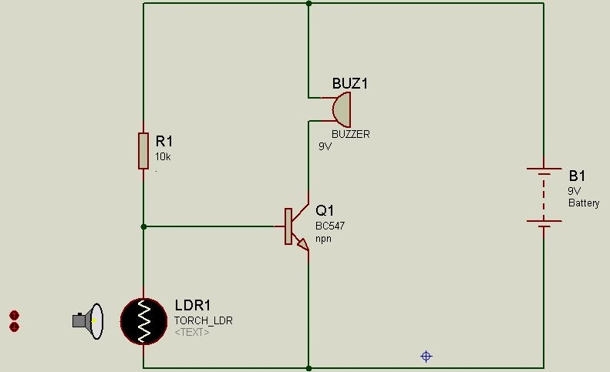

**Components**

1. BC 547 Transistor
2. Viro Board
3. Light Dependent Resistor (LDR)
4. Buzzer
5. 10k Resistor
6. Connecting Wires
7. Battery (9V)
8. Laser
9. Light Emitting Diode (LED)

**Working Principle:** The working principle of Laser Light Security System is based on **LDR**. This resistor works on the principle of **photo conductivity**. It is nothing but, when the **light** falls on its surface, then the material conductivity reduces and also the electrons in the valence band of the device are excited to the conduction band.